

Big Data Analytics
Assignment One: EV Population Dataset
MR. AYEBARE KAGINA MANZI
09.10.2024
─
Remmy Bisimbeko
Masters of Data Science and Analytics
B26099
J24M19/011

Introduction
Electric Vehicles have completely disrupted the Motor Vehicle industry. Big players like Tesla have taken an early lead into this niche market setting pace and older manufacturers quickly fumbling to join in on the action and share the market share.
In this assignment, we were tasked to use the power of visuals to tell a story and communicate powerful insights and trends to management aiming to drive business decisions.
Let us look at the visuals

EV Car Distribution
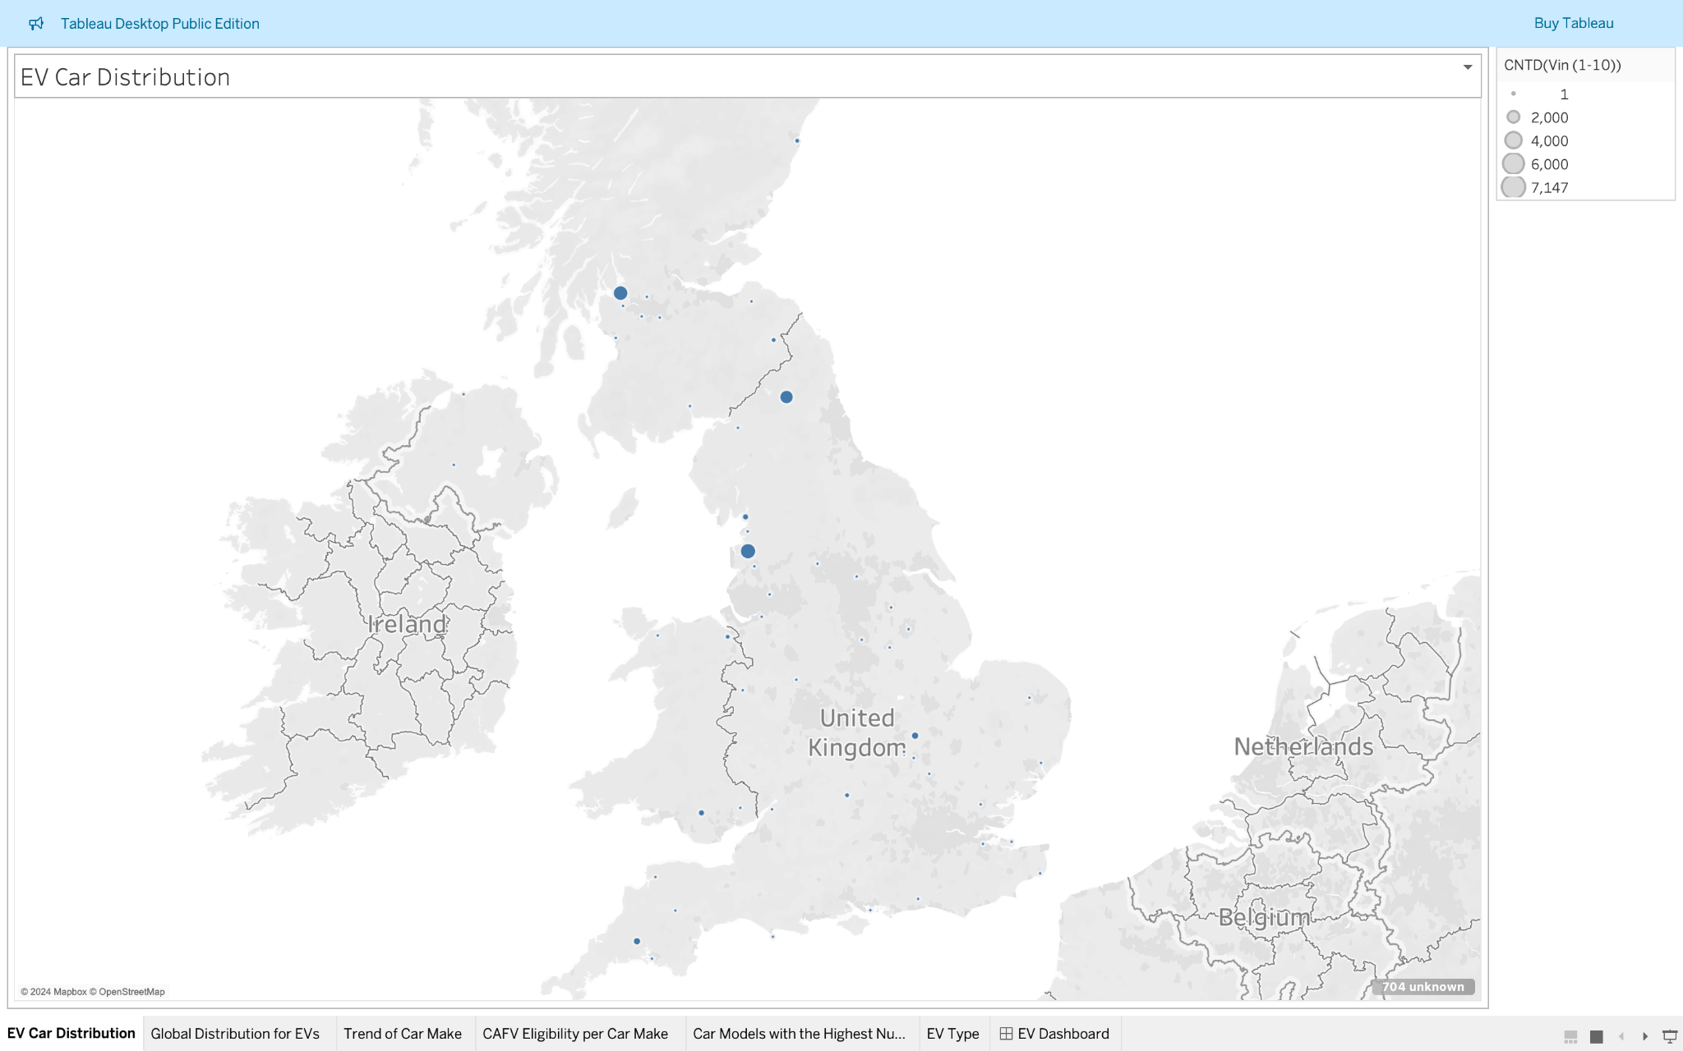

Observation
The Data presented before us evidently portrays that most EVs are located in regions/Counties in Northern UK. And, a lower number distributed in the lower regions of the UK.

Recommendation
Car manufacturers need to set up more charge stations in areas with low EVs to increase sells
Regions with lower Electric Vehicles need not only a cultural shift to start accepting EVs as fully performant cars.
Also, the governments through tax holidays can incentivise car manufacturers that produce cars with lower emissions affecting the carbon footprint and other factors affecting climate change
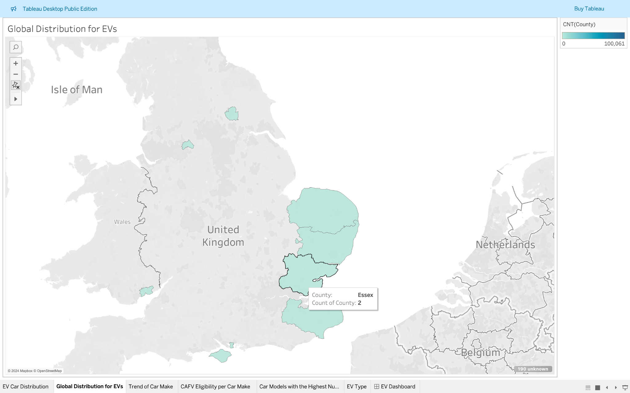

Trend of Car Make over time
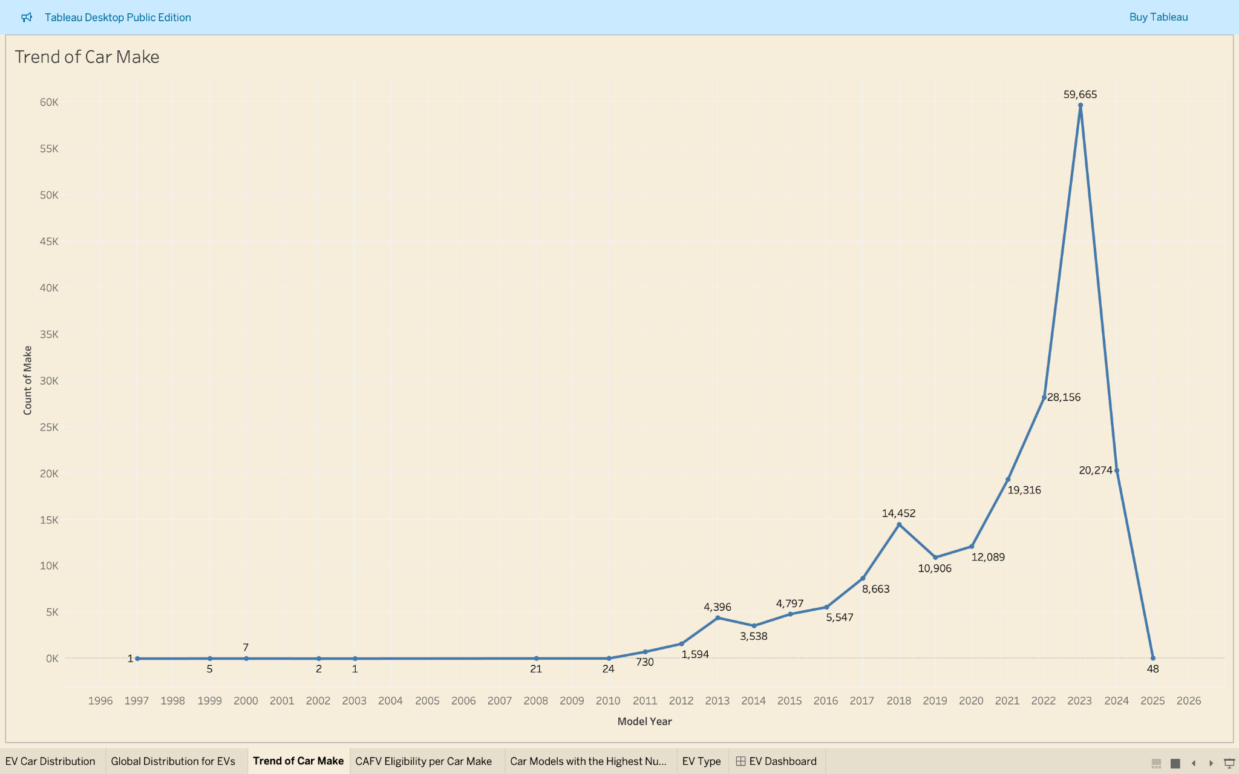
Trend is normally visualized best with a line graph.

Observation
A trend of Car make over the years quickly shows that car manufacturing peaked in 2023. There was a slight dip around 2018 to 2020 due to the Covid Pandemic.
A simple drill down showed that the Tesla was leading the trend with mostly the Model Y having its highest at 26,902.

Recommendation
Other Car Manufacturers need to take notes and follow why Tesla is leading.
Tesla continues to drive innovation through extensive Battery research increasing range of their entire fleet, autonomous driving and software updates through the air.
With a Supercharging Network widely spread across the world, it makes it easier for new entrants into the EV space to buy Tesla mainly because of the availability of their extensive charger network.
The model Y is particularly popular since it is an SUV with great range and a third row of seating.
Most EVs are still figuring this to catch up with Tesla that have the first mover’s advantage

CAFV Eligibility per Car Make

Observation
Highest Clean Alternative Fuel Vehicle (104,636) is unknown as battery range has not been researched. And the lowest, (20,708) is Not eligible due to low battery range

Recommendation
More research need to be invested into increasing Battery range
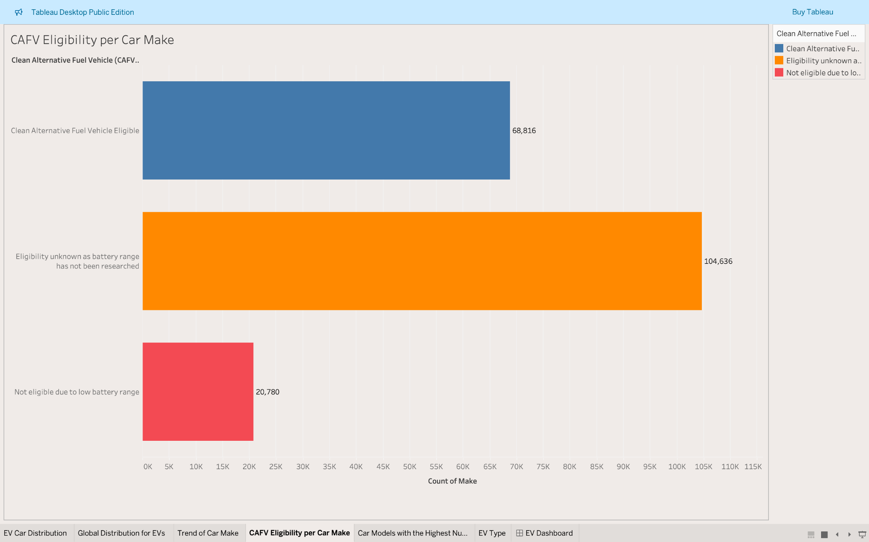

Car Models with the Highest Numbers per year

Observation
A quick glance points out that the Model Y possesses the Highest numbers in 2023. This is also true for years 2024, 2021 and 2018. Other Tesla models also make a presence such as the Model 3 in 2023.
Other car models are not as significantly successful as the Tesla models as suggested by the data.

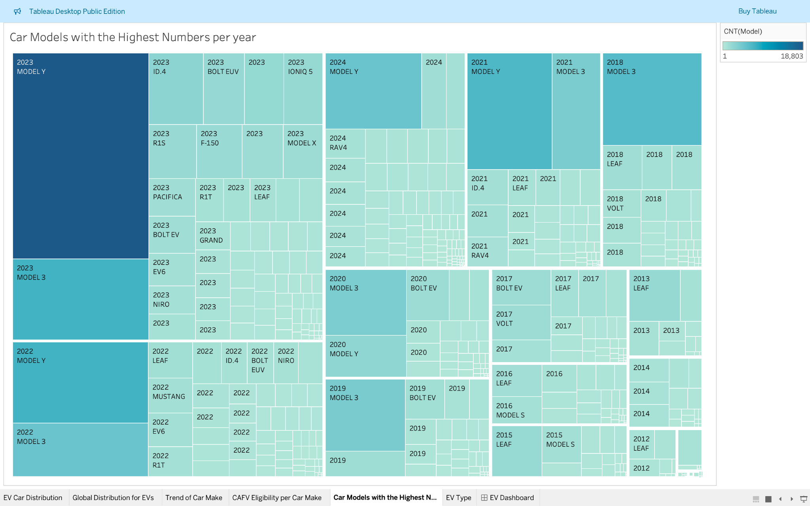

Recommendation
Tesla has higher numbers of EVs across the board over all other manufacturers.
And since they are more popular, production over the years a proved that they are making more and more of these specific models which is translated into more sells

EV Type

Observation
From the simple Pie chart, Battery Electric Vehicles (152,179) are clearly more than the Plug-in Hybrid Electric Vehicles (42,053)
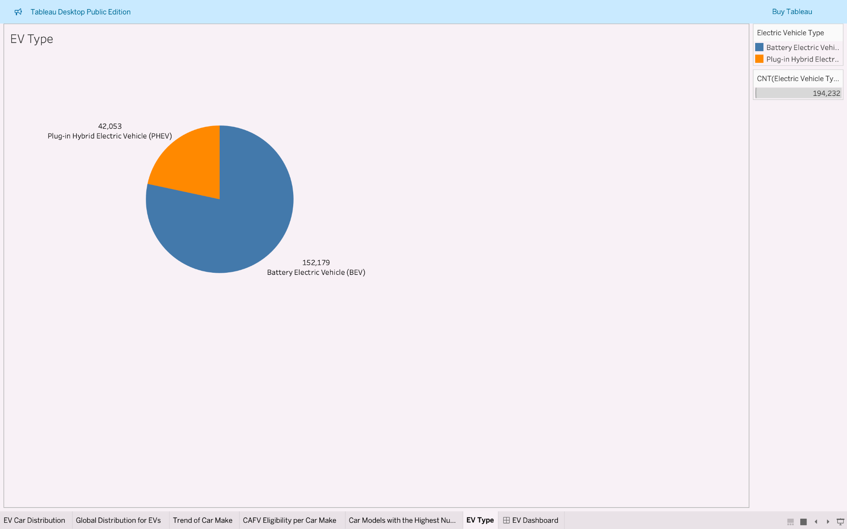

Recommendation
Governments across Europe are giving out Tax holidays and incentives to countries with motor vehicles with less carbon emissions. These manufactures tend to be more competitive in the industry by utilizing and reassigning this money into Battery research and increasing miles for their vehicles.
Also, the market tends to be drawn to vehicles that are fully electric and rather cars that are still using regular combustion fuel.

EV Dashboard
